|  |
| --- |
| Close-up image showing the leaf-sides of two oversized books side-by-side on a bookshelf, with additional books in soft focus background |
| MS Word  Basics |
| |  |  |  | | --- | --- | --- | | Dishi Shrivastava |  |  | |

**Microsoft Word Basics**

**Opening MS Word**

Opening MS Word works like any other Windows application.

Click the **Start** button and select **Microsoft Word** from the list of programs shown in the menu of available programs. Select **Word** by placing the mouse pointer on the icon or title and click it to begin. *Note:* There are numerous ways to accomplish almost every command in Windows.

Opening Word automatically creates a new document, OR once Word is running, you may select **File** and then select **New**, or simply click the **Blank Page** button in the Menu Bar in the upper left corner.

**Exiting MS Word**

Exiting MS Word also works the same for other Windows XP applications.

Click on **File** (left-hand corner on the Menu Bar), and then click on **Exit**, OR click on the red and white X button in the upper right corner of the screen (Title Bar).

**Closing a Word Document**

Closing a document allows you to close the document you are working on without closing MS Word.

Click on **File** (left hand corner on Menu Bar), then click on **Close**, OR close an open Word document by clicking on the BLACK X in the Menu Bar (upper right corner, second line).

Once the file is closed, you may start a New document, Open an existing document, or Exit as described above.

As with most Windows programs, MS Word will take care of your files when you Exit or Close. If you have open files with unsaved changes, Word will prompt you to save or abandon the changes in each file that was open before actually exiting.

**Microsoft Word: Getting Started**

**Create First, Format Later**

Sometimes it is important to get the words you are trying to say out, onto “paper” in the simplest manner, worrying about how the document looks later. Once your data or words are written, you can then concentrate on formatting it – the font, size, indentations, centering, numbering, etc.

**Mouse Pointer vs. the Cursor**

When you move the mouse pointer around, it changes. When the mouse pointer is inside the Word document text area, it looks like a large “I”. When you stop moving it and click on a location, it becomes a blinking dark line which is called the cursor. This is where Word will insert the next character or complete the action you have requested. When you move the mouse pointer outside the text area, to select a button or a scroll bar, the mouse pointer turns into the standard “white arrow.”

**Buttons Have Descriptions**

All of the buttons on the Standard and Formatting toolbars have a descriptive name. There is no need to try and memorize all the buttons. To get a brief description of what a button does, simply move the mouse pointer to the button and rest it there for a moment and the name will appear.

Move the mouse pointer over the Bold B key. The word Bold appears below the key to give description of what the button does.

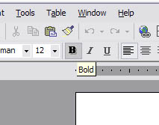

**Microsoft Word: Editing Your Document**

**Moving Around Using the Arrow Keys or Mouse**

You may move your cursor to the right, the left, and up or down by using the Arrow keys.

You may move the cursor around by moving the mouse pointer to the place you have in mind and clicking the mouse.

If you have not done a lot of typing and don’t have extensive experience with the mouse, you may find the arrows to be the easiest method of moving around. Once you have conquered the mouse, you will only occasionally use the arrow keys.

*Note:* You cannot have the cursor past the end of the document using either the Arrows or the mouse.

**Deleting Characters or Words**

There are a number of ways to delete characters or words. We will explore many of them. You should be aware that you will develop preferences for getting your work done that may be different from your neighbor. MS Word is a very flexible application and there are many ways to get the same job done.

You may Delete characters moving to the right using the Delete key, or Delete words moving to the right by typing CTRL Delete.

You can delete characters moving to the left by using the Backspace key (back-arrow), or Delete words moving to the left by pressing CTRL Backspace.

You may delete characters or words by selecting them by highlighting them with the mouse and then using the Delete key.

You can delete characters or words by selecting them by highlighting them with the mouse and then click the Edit button on the Menu Bar and then clicking Clear (delete).

**Undo and Redo or Repeat Buttons**

Don’t panic if you touch a wrong key, or do something that seems to change everything from the way you want it.. There is an Undo Key and a Redo key.

The Undo and Redo keys are found on the Formatting Toolbar. They are represented by curved arrows. Undo is on the left and curves backwards, and Redo or Repeat is on the right.

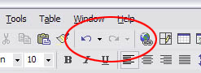

Click the Undo button. The last center that you deleted should reappear unless you have done some other command since then. Click Redo and it will be gone again.

Undo and Redo are also on the Edit Menu. Click on Edit and the first two buttons are Undo and Repeat (or Undo). Redo is grayed out meaning it is unavailable until you have hit the Undo key.

**Bold, Italics, and Underline**

These keys are found on the Formatting Toolbar and can easily dress up your document and make it appear more professional. They are represented by the B, I, and U.

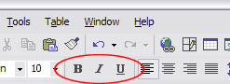

**Font Size and Fonts**

Changing the size of words in your document is one of the best ways to call attention to specific parts or provide a title or sections.

You can change the size of the whole document, or just a word, or just a character. My paragraph above is in 12-point size. We will increase the size to 14. Select and highlight the entire paragraph using your mouse.

With the paragraph selected, click on the point that is probably a 10 or 12. The standard text in documents varies between 9 and 12. For effect, we’ll select 14.

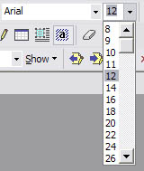

Click on the down arrow to the right of the point size. The matching size in the drop down menu is highlighted. Either select 14 by moving the mouse pointer to 14, or type 14 when the number in the box is highlighted. Your standard choices are 8 through 72 but you can enter any number between 1 and 99.

Let’s decrease the size of the words within the parentheses to 8 point. Select the words within the parenthesis by going to the beginning or end of the phrase, clicking with the mouse and then going across the words to select them all. Then click on the down arrow to the right of the 14 and select the number 8. The text within the parentheses will now appear smaller than the rest.

**Microsoft Word: View/Zoom**

Not only can you change the size of the characters in your document, but you can also zoom in or out to get a better look at your document. Changing font size actually modifies the contents of your document. The View does not change anything other than your ability to see it better.

Your view is likely at 100% as shown in the size window of the Standard Toolbar. You can increase or decrease the size of the view (zoom in or out). Look at your percentage size to remember the current size and then experiment with selecting different sizes to view your work.

**Arrange All**

Under the Window option, clicking on **Arrange** all when you have more than one Word document open displays them so you can go back and forth between the documents seeing both at the same time.

# Microsoft Word: File Menu

A number of important tasks that you will use frequently are listed under **File** on the Task bar.

**New** - the graphic of a white sheet of paper on the upper left, allows you to create a new document and gives you several templates to choose from include memos, letters, faxes, resumes, and so forth.

Click on **New** and you will see the **General** tab, which allows you to create a new document using the standard format (Normal) and is the same as clicking on the blank page button that is in the upper left corner.

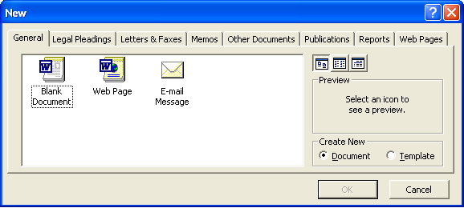

**Open** a document is the same as clicking on the yellow folder with a forward arrow. It allows you to browse for a document type that you want to open. You can have multiple documents open at the same time.

**Close** allows you to close a document. If there are unsaved changes, Word will prompt you to save or abandon the changes before actually closing it.

**Save** allows you to update changes you are making to the document and stores it on the hard drive so that you won’t lose your work that has been completed if there is a power interruption or other system malfunction – computers can malfunction, and usually do so at the most inconvenient times. Save your work often. If you have created a new document and not given it a name, the first time you Save, it will take you to the Save As dialog box.

**Save As** allows you to tell Word the name of your document and the folder that you want to store it in. It also allows you to select different formats so that you can save a copy of your Word document in a WordPerfect or Corel format, for instance, for compatibility with other computer systems.

**Versions** allows you to specify that you will be making multiple changes to a document and that you want to keep the changes separate with an automatically assigned version number rather than changing the file name each time.

**Page Setup** allows you adjust the size of your margins, to turn your document from the standard Portrait to Landscape.

**Print Preview** allows you to see how your document will look when it is printed. If you are doing a letter and want to have it spaced evenly on the page, it will help you to see where the top margin ought to be.

**Print** allows you send a file to the printer to be printed.

**Send To** allows you to send your document to a fax machine or into email to send it to others.

**Properties** describes your document as the system sees including the date it was created, last modified, etc. It also lists statistics on the number of pages, paragraphs, line, words, characters, etc.

Next in the list you will see the last few documents you have edited/created on the computer along with the path to where they were saved. This can be helpful when you can’t remember what you called a document or where you saved it. It is also a very easy way to open that document without having to enter the path. Just double click on that line.

Lastly, **Exit** to exit from Word.

**Microsoft Word: Tables & Columns**

A table is a grid of rows and columns that intersect to form cells. The lines that mark the cell boundaries are called gridlines. It’s often easier to read or present information in table format than in paragraph format. Using Word’s table feature, you can create a table and insert text, pictures, or another table into the table’s cells.

**Creating a Table**

There are two ways to create a table:

1. Insert a table by using the Insert Table dialog box or the Insert Table button on the Standard Toolbar.

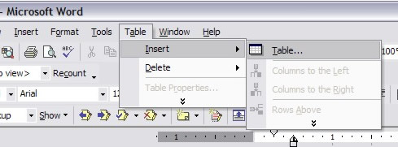

2. Draw a table by using the Tables and Borders Toolbar.

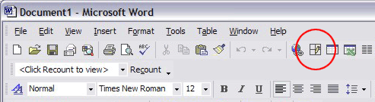

**Columns, Rows and Cells in a Table**

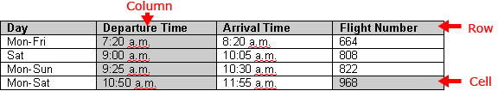

Note: You can apply formatting options to tables, such as borders and shading, or display a table with or without gridlines.

**Keying and Editing Text in Tables**

Keying and editing text in tables is similar to working with text in paragraphs. The Insert and Delete keys work the same way. But if you key text in a cell and press Enter, a new paragraph is created within the same cell. The first row of a table is often called the header row, in which each cell contains a heading for the column of text below it.

**Shortcuts for Moving Between Cells**

|  |  |
| --- | --- |
| *To move to* | *Press* |
| Next Cell | Tab |
| Previous Cell | Shift + Tab |
| First Cell in the Current Row | Alt + Home |
| Last Cell in the Current Row | Alt + End |
| Top Cell in the Current Column | Alt + PgUp |
| Last Cell in the Current Column | Alt + PgDn |

**MS Word shortcuts**

|  |  |
| --- | --- |
| **Mouse shortcuts** | **Description** |
| **Click, hold, and drag** | Selects text from where you click and hold to the point you drag and let go. |
| **Double-click** | If double-clicking a word, selects the complete word. |
| **Double-click** | Double-clicking on the left, center, or right of a blank line makes the alignment of the text left, center, or right aligned. |
| **Double-click** | Double-clicking anywhere after text on a line will set a [tab stop](http://www.computerhope.com/jargon/t/tabstop.htm). |
| **Triple-click** | Selects the line or paragraph of the text that the mouse triple-clicked on. |
| **Ctrl + Mouse wheel** | Zooms in and out of document. |

**Undo and Redo**

Because we all make a lot of typos and errors while working, the first ones on this list have to be Undo and Redo: Ctrl+Z and Ctrl+Y. The Ribbon shortcuts are on the Quick Access Toolbar. Undo is depicted by an arrow curved to the left in both Word and Excel. However, in Word, Redo is shown as a circular arrow, and in Excel, it’s an arrow that curves to the right.

**Cut, Copy, Paste**

You can copy and paste a paragraph using the original shortcut keys: Ctrl+C for copy (or Ctrl+X for Cut), and then Ctrl+V for paste.

The Ribbon shortcuts are Alt+H-C for Home, Copy (or Alt+H-C-C for Home, Copy, Copy in Excel) and Alt+H-X for Home, Cut in both Word and Excel.

For Paste, it’s Alt+H-V-K for Home, Paste, Keep Source Formatting in Word, and Alt+H-V-P for Home, Paste, Paste in Excel.

**Select or Select All**

Another shortcut that’s often used with Cut, Copy, Paste is Ctrl+A, which means Select All: That is, select the entire document, spreadsheet, or file. On the Ribbon, it’s ALT+H-S-L-A (Home, Select, All).

**Print and Print Preview**

Print is simple, but many users go straight to Print Preview as a final sanity check on margins and layout. For Print, it’s Ctrl+P or Ctrl+Shift-F12. Print Preview is Ctrl+F2.

**Other shortcuts in word**

|  |  |  |  |  |  |  |  |  |
| --- | --- | --- | --- | --- | --- | --- | --- | --- |
| |  | | --- | | Ctrl+N | | Open a new word document quickly. | | |  | | --- | | Ctrl+X | | | Cut- Removes the selection from the active document and places it on the clipboard. | |
| |  | | --- | | Ctrl+O | | Opens a previously saved document. | | |  | | --- | | Ctrl+C | | | Copies the selection to the clipboard | |
| |  | | --- | | Ctrl+W | | Closes the active window, but does not Exit Word. | | |  | | --- | | Ctrl+V | | | Paste - Inserts the contents of the clipboard at the insertion point (cursor) or whatever is selected. | |
| |  | | --- | | Ctrl+S | | Saves the active document with its current file name, location and format. | | |  | | --- | | Ctrl+A | | | Selects all text and graphics in the active window. | |
| |  | | --- | | Ctrl+P | | Prints the active file, also gives the opportunity to change print options | | |  | | --- | | Ctrl+F | | | Find - Searches for specified text in the active document | |
| |  | | --- | | Alt+F4 | | Exit - Closes Microsoft Word. | | |  | | --- | | Ctrl+B | | | Bold - Formats selected text; make text bold, or remove bold formatting | |
| |  | | --- | | Ctrl+Z | | Undo the last action. This selection can be repeated several times. | | |  | | --- | | Ctrl+I | | | Italic - Formats selected text; make text italic or remove italic | |
| |  | | --- | | Ctrl+Y | | Redo - After an action has been undone, it can be reinstated in the document. | | |  | | --- | | Ctrl+U | | | Underline - Formats selected text; make text underlined or remove underline | |
| **If you want to move the cursor** | | | | | | | |
| http://www.internet4classrooms.com/1carribm.gif | | One character to the right | | http://www.internet4classrooms.com/1carlibm.gif | | One character to the left | |
| http://www.internet4classrooms.com/1wordrtibm.gif | | One word to the right | | http://www.internet4classrooms.com/1wordleftibm.gif | | One word to the left | |
| http://www.internet4classrooms.com/enddocibm.gif | | To the end of a document | | http://www.internet4classrooms.com/begindocibm.gif | | To the beginning of a document | |